**Analysis of Macroeconomic Policies in Germany: Post Pandemic**

**INTRODUCTION**

Germany is the most prosperous economy in terms of GDP at PPP across all of the Eurozone. The GDP of the nation was recorded at 3.57 trillion USD while GDP per capita was estimated at 50,314 USD for the year 2021 (O'Neil, 2022). GDP per capita at PPP is 52,930.81 USD. It is a major player in the automobile industry. It is also one of the largest importers and exporters succeeded by only China and the USA. Germany’s post-pandemic economic growth has been slow yet steady in pace. Surveyed as the most credible and investment-friendly country in Eurozone with COVID-19 recovery plans. The report aims at reviewing Germany’s economic performance based on macroeconomic parameters such as foreign trade, bilateral trade relations with other nations, Economic structure, unemployment, and Inflationary trends since March 2021.

**Economic Freedom and Structure**

The economy of Germany is that of a social market economy which means that a free market capitalistic economy is constructed alongside social policies to ensure fair competitiveness of the free market while making space for a welfare state. The service sector comprises 70% of the total GDP, the manufacturing and industry sector contributes at 29.1% while the agricultural sector does 0.9%. States with minimal to no participation in the market are placed higher on. (GlobalPopertyGuide) Germany on a scale of 0-100 stands at 73.80 on the scale of Economic freedom, Germany measures low on this scale due to its socialistic capitalism approach to markets.

**EXPORTS – IMPORTS, BOP, & TRADE RELATIONS**

The nation’s total export stood at € 130.03 billion in May 2022 as against € 109.26 billion in May 2021. The major exports are composed, of automobile vehicles and accessories, Chemicals, pharmaceutical products, and Machinery. The majority of the export freights to the US followed by France and China. Formerly Russia was a major importer of German goods. The sanctions have reduced Germany’s export to Russia by 62%. German imports in May 2022 stood at €129.80 billion as compared to €97.15 billion at the same time last year. A steep rise of 33.6% in imports on a Year on Year basis. The nation imports majorly from the European Union, China, Russia, and the USA. (Amaro, 2022). The country’s import includes optical products, electronics and computer, machinery, automobiles, crude oil, and natural gas. The nation has always prided itself on consistent trade surpluses, 2016 Germany achieved a recording breaking trade surplus of USD 270.05 billion. Germany for the first time in May 2022 in 3 decades faced a trade deficit due to a 30% hike in import prices and a significant drop in exports to Russia because of the war (Ergöçün, 2022). The hike in energy prices had been due to an increase in the prices of natural gas and crude oil. Bottlenecks in the global supply chain and the Russian war on Ukraine are the driving factors behind the surge in energy prices for Germany. Natural gas recorded a price hike of as high as 235.6% in May 2022 (Ergöçün, 2022). Energy prices form a significant amount of German imports from Russia.

Germany is working to minimize its dependency on Russian imports post the Russian war on Ukraine (The Statesman, 2022). Russia is a major exporter of natural gas and oil to its global counterparts. European Union has been promptly acting to cut Russian imports, especially in the energy sector. It plans to bring down its imports of Russian oil by 90% (Kennedy, 2022). Germany tends to import a majority of its energy requirement of oil and natural gas from Russia. Even with a fast-paced transformation to green and sustainable energy; the lingering impact of the pandemic leading to supply chain bottlenecks, increasing demand for climate policies, and above all, the Russia-Ukraine war has put a disruption on the energy infrastructure of the German economy. The declining Euro against the dollar has also been one of the reasons for an increase in the value of imports by Germany. A nation of trade surpluses is currently facing deficits due to high import costs, inflationary trends, and its race against time of being self-reliant for its energy needs.

**INFLATION, INTEREST RATES & EMPLOYMENT**

The country due to high import costs is experiencing average inflation of 6.70% as of June 2022 (Inflation Germany, 2022) whereas at the same time this year in 2021 Germany experienced an average inflatio rate of 3.14% which is relatively lower (Inflation Germany , 2021). Post pandemic the demand picked up pace which was met with bottlenecks in the global supply chain, high input costs, deteriorating Euro, and high oil and gas prices which ultimately resulted in inflationary trends. The government has cut fuel taxes to counter the effects of high fuel prices (Delfs, 2022). The nation is also working on completing its billion-dollar energy projects in order to be self-reliant for its energy needs as much as possible. This in turn has also led to an increase in deficits. The decrease in fuel taxes has had an effect on inflation as the nation after several months registered a dip in the inflationary rate.

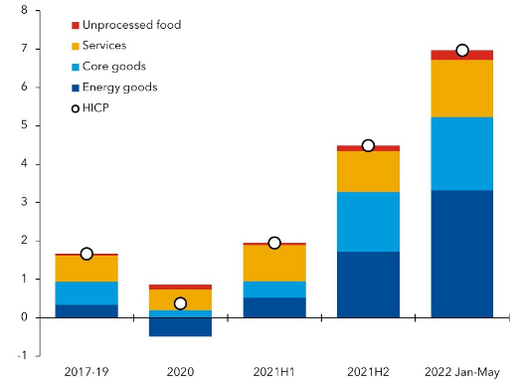

**Figure 1: Price Inflation in Germany (IMF, 2022)**

In an attempt to curb inflation the European Central Bank for the first time in 11 years has increased interest rates (Firstpost., 2022).

Germany as a part of the EU has Euro as its currency. Euro over time has had an upper hand over the US $. In 2021 it was doing well at an exchange rate of 1.20$/Euro. Since then it has registered a decline to a decade low of 1.02$/Euro. The weakening Of the Euro can be attributed to many factors such as Brexit, lower growth of the European Union, and uncertainty.

.Germany has done remarkably well to provide employment to its citizens even amidst pandemic and post it. In 2020 the nation recorded an all-time low unemployment rate at 5% even with the pandemic disrupting it at 5.9%, the country has picked up the pace and brought down unemployment to 5.2% in 2022.

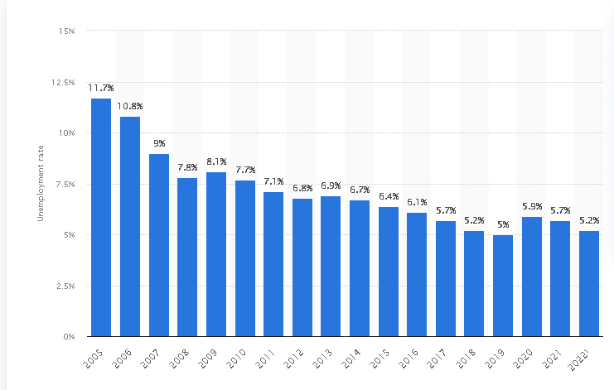

**Figure 2: Unemployment in Germany over the years. Source STATISTA 2022 (STATISTA, 2022)**

**CONCLUSION**

Germany with respect to its GDP is the biggest nation in Europe, 4th largest by nominal GDP among all countries, and 5th by the measure of GDP (PPP). The nation is composed of highly skilled labor which forms the backbone of the nation. It has consistently maintained a trade surplus over the decades. Its response to COVID-19 was reassuring as its healthcare was successfully able to take on the pandemic. Even with the declining Euro and the ongoing energy crisis because of the Russian war on Ukraine, it still has managed to bring down unemployment and already has plans for inflation and energy crisis in action. Given all, even with slow growth and a delay in reducing deficits, the country will be back on its path of growth.

# References

Amaro, S. (2022). *Germany’s much-vaunted trade surplus disappears as import prices surge.* CNBC. Retrieved from https://www.cnbc.com/2022/07/05/germanys-much-vaunted-trade-surplus-disappears-as-import-prices-surge.html

Delfs, A. (2022). *Germany to Cut Fuel Tax to Help Ease Burden of Energy Prices.* Bloomberg News. Retrieved from https://www.bnnbloomberg.ca/germany-to-cut-fuel-tax-to-help-ease-burden-of-energy-prices-1.1742278

Ergöçün, G. (2022). *Germany's import prices up over 30% in May.* Retrieved from https://www.aa.com.tr/en/economy/germanys-import-prices-up-over-30-in-may/2626650

Firstpost. (2022). *Bitter Half: European Central Bank hikes rates for first time in 11 years, recession fear haunts continent.* Retrieved from https://www.firstpost.com/business/bitter-half-european-central-bank-hikes-rates-for-first-time-in-11-years-recession-fear-haunts-continent-10941031.html

GlobalPopertyGuide. (n.d.). *Economic Freedom in Germany | Investment Freedom in Germany.* Retrieved from https://www.globalpropertyguide.com/Europe/Germany/economic-freedom

IMF. (2022). *Germany Faces Weaker Growth Amid Energy Concerns.* IMF. Retrieved from https://www.imf.org/en/News/Articles/2022/07/21/cf-germany-faces-weaker-growth-amid-energy-concerns

Inflation Germany . (2021). *Inflation Germany 2021.* inflation.eu. Retrieved from https://www.inflation.eu/en/inflation-rates/germany/historic-inflation/cpi-inflation-germany-2021.aspx

Inflation Germany, 2022. (n.d.). *Inflation Germany 2022 – CPI inflation Germany 2022.* inflation.eu. Retrieved from https://www.inflation.eu/en/inflation-rates/germany/historic-inflation/cpi-inflation-germany-2022.aspx

Kennedy, N. (2022). *EU agrees on partial ban of Russian oil imports.* CNN. Retrieved from https://edition.cnn.com/2022/05/30/energy/eu-russian-oil/index.html

O'Neil, A. (2022). *Germany: Gross domestic product (GDP) per capita in current prices from 1987 to 2027.* STATISTA. Retrieved from https://www.statista.com/statistics/295465/germany-gross-domestic-product-per-capita-in-current-prices/

STATISTA. (2022). *Unemployment rate in Germany 2022| STATISTA.* Retrieved from https://www.statista.com/statistics/227005/unemployment-rate-in-germany/#:~:text=Annual%20average%20unemployment%20rate%20in%20Germany%20from%202005,%205%20%25%20%209%20more%20rows%20

The Statesman. (2022). *“Winter is Coming”, without Russia’s help can Germany brave the cold?* Retrieved from https://www.thestatesman.com/world/winter-coming-without-russias-help-can-germany-brave-cold-1503089518.html